Estimated Cost for the Project:

1-Arduino:

We will use Arduino MEGA 2560 with a WI-FI connector.

🡪1000-2000 L.E

2-Light Sensor:

TSL2561 or BH1750FVI

🡪200-300 L.E

3-Humidity and Temperature Sensor:

DHT22 or BME280

🡪200-350 L.E

4-Soil Moisture Sensor:

🡪100-300 L.E

5-Water level Sensor:

Ultra Sonic Sensor

🡪50-200 L.E

6-Fan:

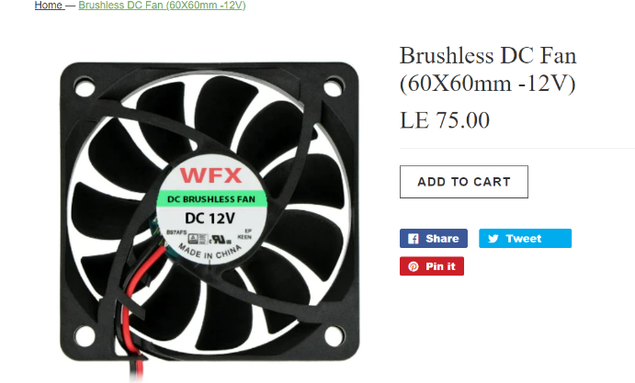

🡪50-200 L.E

7-Power Supply:

Mean Well LRS-75-5 power supply.

🡪400-600 L.E

Another option is a power bank.

8-LEDs:

There are a lot of common choices.

🡪50-200 L.E

9-Connection Cables:

🡪100-200 L.E

Estimated Cost for Hardware Component:

🡪2150-4350 L.E